Practical 13 — PHP JSON API and AJAX/Fetch CRUD

Aim
To expose students as a JSON API and drive full CRUD from the browser with Fetch and no page reloads.

Theory
An API returns data, not pages. The browser sends structured requests and re-renders the table from the JSON reply, keeping the user in place.
- One endpoint of about 14 KB serves list, create, update and delete with status codes and JSON bodies, guarded by role and anti-forgery tokens.
- A browser module of about 12 KB issues the requests, debounces search, and refreshes rows, counts and pager from replies without reloading.
- A dedicated live-list page hosts the no-reload table alongside the classic management page for comparison.
- Role failures return forbidden rather than data, and anonymous calls are rejected as unauthenticated.
- Network-tab evidence (method, status, JSON body) is the natural proof and needs a live server.

Procedure
- Built the JSON endpoint with list, create, update and delete actions, validation, role checks and token checks.
- Wrote the browser module with debounced search, request handling and in-place table updates.
- Added the live-list page wiring the module to the endpoint.
- Inspected endpoint, module and live page on disk; live request transversal was not re-run here without Apache and MySQL.

Screenshots
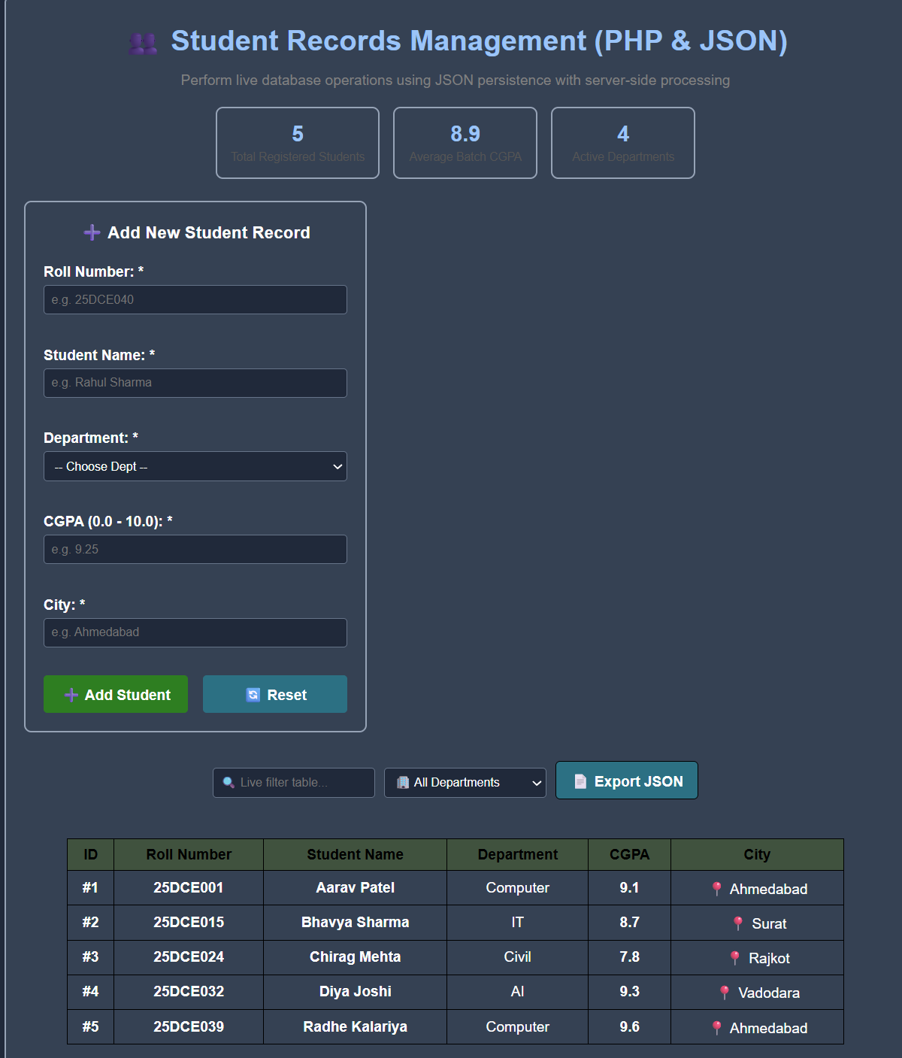

GitHub Repository Link
Practical repository : https://github.com/Rkpatel34/StudentHub/tree/main/studenthub

Conclusion
Practical 13 decoupled data from pages and made student administration instant.

